

**LexisNexis® Attract For Commercial Auto Underwriting (driver model)**

**Quickbase #1483**

**Final**

**Product Market Requirements (PMR) Document**

Version 1.7

**CONFIDENTIAL & PROPRIETARY**

The recipient of this material (hereinafter “the Material”) acknowledges that it contains confidential and proprietary data the disclosure to, or use of which by, third parties will be damaging to LexisNexis Inc and its affiliated companies (hereinafter “LexisNexis”). Therefore, recipient agrees to hold the Material in strictest confidence, not to make use of it other than for the purpose for which it is being provided, to release it only to employees requiring such information, and not to release or disclose it to any other party. Upon request, recipient will return the Material together with all copies and modifications, if any.

All names in the text, or on the sample reports and screens shown in this document, are of fictitious persons and entities. Any similarity to the name of any real person, address, school, business or other entity is purely coincidental.

The trademarks, logos, and service marks (collective the “Marks” or “Mark”) appearing in this document are registered and unregistered Marks of LexisNexis and others. The information contained herein does not constitute a grant of any license or right to use any Mark displayed on this document. LexisNexis aggressively enforces its intellectual property rights.

**TABLE OF CONTENTS**

1. Documentation Revision History 4

2. Documentation Guidelines 4

3. Key Contacts 5

4. Vertical Market 5

5. Target Implementation Date/Quarter 5

6. Initiative Purpose 5

7. Dependencies 6

8. Product/Service Requirements 6

9. Contributory Requirements 12

10. Rule Plan Requirements 12

11. Modeling Requirements 12

12. Third Party Data and Vendor Requirements 13

13. Volume 13

14. Account/Customer Setup 13

15. Support Tool 14

16. Management Reports 14

17. Consumer Disclosure 14

18. Billing 14

19. Testing 15

20. Legal 15

21. Security Assessment 15

22. Sales Tax 15

23. Appendix A – Modeling Document 15

24. Appendix B - CR# 128 15

1. Documentation Revision History

|  |  |  |  |
| --- | --- | --- | --- |
| **Version** | **Date** | **Author** | **Remarks/Comments** |
| 1.0 | 09-15-13 | Connie Fitzsimmons | First draft. |
| 1.1 | 11-01-13 | Connie Fitzsimmons | Updates after first PMR review 10-29-13 with account setup, MVR clarification re: DHDB/DUP, no reason codes/model indicators, model inquiry and data attributes. |
| 1.2 | 11-26-13 | Connie Fitzsimmons | Added Account Setup (f.k.a MBSi Requirements), and renumbered the other changes. |
| 1.3 | 12-09-13` | Connie Fitzsimmons | Updates after discussion with the Vertical and MBSi Teams. |
| 1.4 | 12-12-13 | Connie Fitzsimmons | Added 2 score model ids. |
| 1.5 | 12-20-13 | Connie Fitzsimmons | Updated info for Data Enhancement, MVR, and rule plan id. |
| 1.6  Baseline | 01-07-14  02-07-14 | Connie Fitzsimmons | Clarification on MVR and Data Enhancement indo.  After meeting with Legal, added Minor clarification on DE. |
| 1.7  Final | 03-19-14  03-26-14  04-01-14  04-08-14 | Connie Fitzsimmons | Added product name, defined contributory, added updated modeling document.  Updated name, MVR info, data, 8c, no model indicators and tax ?s.  Updated redline from Legal and added tax decision.  Added Legal approval dates. |
| **Change Request** |  |  |  |
| CR# 128 | 03-19-14 | Connie Fitzsimmons | Added report codes. |

1. Documentation Guidelines

|  |  |
| --- | --- |
| **Document**  **Author** | This originates from the market vertical team and expanded on by the Product Manager or New Product Execution team member. |
| **Document Purpose** | The document defines purpose, requested product solution functionality, exceptions, performance requirements, legal and regulatory compliances, and operational requirements. |
| **Document Audience** | The Technology and *Rules Business Analyst teams will use this document to determine the system and technical specifications. |
| **Expected Outcome** | Ensure a common understanding among the project delivery team, of the market problem being solved and the proposed solution. |
| **Document Reviewer** | Market Vertical, Technical Design teams, and the appropriate operational stakeholders. Refer to the [Product Release Checklist](http://teamsites.choicepoint.net/insurance/pncmkt/pmm/Templates/Prod%20Dev%20-%20Product%20Release%20Checklist/Product%20Release%20Checklist%20-%20RACI.xls) for a complete list. |
| **Document Approver** | Document must be approved by Technical and Market Vertical teams to ensure all Vertical requirements are met and clearly enunciated. |
| **Document Destination** | New Product Execution Team SharePoint document repository. |
| **Additional**  **Helpful Tips** | Additional requirements and approvals may be required if other groups such as Rules Business Analysts and Modeling Analytics are affected. This document may contain more headings/categories than applicable for your product solution. Simply indicate NA-Not Applicable, to illustrate that all areas were proactively considered. |

1. Key Contacts

|  |  |  |
| --- | --- | --- |
| **Name** | **Title** | **Responsibility** |
| Mathew Stordy  Hemi Patel | Business Vertical | Responsible for defining product/solution concept based on needs and requirements from the market. |
| Connie Fitzsimmons Susan Goss | New Product Execution | Responsible for defining the business requirements for the initiative. |
| Aaron Hale | Product Management | Responsible for managing the initiative once in production. |
| Ben Saunders | Engineering Project Management | Responsible for the project schedule and coordination of development, testing and production implementation. |
| Rajesh Talreja | Development | Responsible for the design, development and implementation of the initiative into the LN infrastructure. |
| Scott Goss  Matthew Rutland | Rules Business Analyst | Responsible for the Rules functional specifications for integration into the implementation. |
| Dimple Patel/Prithi Rajan | Model Office Testing | Responsible for testing using the Rules functional specifications for integration into the implementation. |
| Becky Champion | Modeling | Responsible for defining and creating the model which will be used for initiative. |
| Nancy O’neill | Customer Test | Responsible for developing appropriate customer test cases. |
| Juan Londono | QC | Responsible for testing system and application functionality as outlined in the PMR. |
| Chris Tolbert/Adrienne Peek | MBSi | Responsible for development of account setup, product configuration, billing, support tool, management reports and consumer disclosure. |
| Denise Lee/Zhibing Lee | Technical Documentation | Responsible for creation and publication of Customer Documentation. |

1. Vertical Market – Commercial
2. Target Implementation Date/Quarter– Q2 2014
3. Initiative Purpose
   1. **Executive Summary** – For the purposes of rating, Commercial insurers who write small to mid-size fleets traditionally collect detailed information related to the vehicles in the fleet. For many insurers, limited driver information such as years of experience, years employed, and age are used in policy rating. Insurers also pull MVR’s on individual drivers and charge for violations and accidents. Commercial insurers desire to gather more detailed information on fleet drivers. This includes driver class (age, gender, and marital status), violation and accident history, credit, and other personal attributes predictive of the risk of loss.
   2. **Market Opportunity** –LexisNexis needs to develop a risk score sourced off of public records and other Non-FCRA data assets.  This score will be utilized when underwriting drivers (commercial auto).
   3. **Financial Objective** –
      1. Year 1 = $200,000.00
      2. Year 2 = $500,000.00
      3. Year 3 = $750,000.00
4. Dependencies
   1. **Assumptions -** Model is complete.

Accounts will need to be setup with Standard Violation Codes, no Customer Specific Codes.

Accounts will not be setup with Driver History Database (DHDB) or Duplicate Order Check (DUP). We are not making any changes to MVR and the way the product is processed today**.**

* 1. **Issues** – NA
  2. **Constraints** – NA

1. Product/Service Requirements
   1. **Overview** –

The Modeling Team will develop a risk score sourced off of public records.

There will be two versions of the Attract for Commercial Auto Underwriting model.  One version that includes MVR attributes and a second version that excludes MVR attributes. The score and model will be Non-FCRA.    
Two models will be built. One model will include Public Record attributes. This model will exclude MVR attributes. A second model will include Public Record and MVR attributes. NO MVR DUP and DHDB data can be used. MVR is considered Non-FCRA because the carrier is ordering on a fleet for use in commercial insurance.

The order from the customer will be the same as used to order a MVR or to access Rules Framework.  The customer inquiry will need Data Enhancement (such as address) to obtain missing information needed for the order to public records.  The inquiry will be in the MVR INFORM or Risk XML format. The LexID for each driver will be used to append the appropriate Public Record and other attributes (depending on which version of model is used) to be consumed by the model to develop the score.  LexID information will not be sent to the carrier.

Data Enhancement Overview:

The inquiry data is enhanced using the Insurance Header data enhancement (appl_id ENH_Data). Submitted data will not be enhanced unless it is determined to be erroneous data (an example would be all zeros in a SSN or DOB). Data sources used for data enhancement are LN Public Records and DMV data. DMV data is only used if the customer credentialing and MBSi account validation allows the data (DMV Affidavits are on file).

The following data will be enhanced if not submitted on the inquiry:

* SSN
* DOB
* Gender
* DLN
* DL State
* Current Address (not used for MVR order)
* Former Address (not used for MVR order)

A rule plan will enhance the inquiry data by ordering Data Enhancement on the first subject only and send results to ISS with or without the MVR (depending on the Model requested). The Data Enhancement data will not be sent to the carrier. Carrier will determine model to be ordered.

If no new data is returned from Data Enhancement, the rule plan will continue to process to MVR. IF Activity File returns a Clear result, the rule plan will continue to ISS. If Activity File result is not Clear, the rule plan will order MVR. MVR information is required for the MVR model. If the MVR Model is ordered and the MVR is a no hit or an error, do not send the transaction to ISS and return the appropriate message to the carrier. MVR and score results will be returned with separate section header records. Any additional personal information contained in the MVR, not sent in by the carrier, will not be returned in the result to the carrier. If multiple MVRs are returned, we will not use multiple MVRs to score and the rule plan will switch to C114 and return the appropriate message indicating that the MVR model wasn’t used for the score. The MVRs will be returned to the carrier.

Additional details will be in the Rules Functional Requirements Specifications (FRS).

The model will produce a score for each driver from 200 to 997, where 200 = highest (worst) risk, 997 = lowest (best) risk, etc. There will not be reason codes/model indicators.

* 1. **Data** – The Attract for Commercial Auto will utilize data attributes from:
* Boca Shell 4.0 (Public Records)
* Length of Driving
* Motor Vehicle Reports (MVRs)

* 1. **Compliance/Restrictions** – DPPA, GLB

The defaults for Insurance, approved by legal are:

The DPPA code to be logged is “6” – For use by an insurer or insurance support organization, or by a self-insured entity, or its agents, employees, or contractors, in connection with claims investigation activities, antifraud activities, rating or underwriting.

The GLB code to be logged is “5” – to protect against or prevent actual or potential fraud, unauthorized transaction, claims or other liability.

We are not making any changes to MVR and the way the product is processed today.

* 1. **Contract Restrictions:** Customer level contracts to include GLB / DPPA language. MVR restrictions will be listed in the contract. This product does not utilize data from C.L.U.E Commercial. However, the business is requiring that a carrier contribute to C.L.U.E Commercial in order to utilize this product in order to encourage contributions to C.L.U.E Commercial.

Contracts should also make sure the prohibition on use of the information for employment decisions is also included in the agreement.

* 1. **Interface** – Interactive Roll to Batch processing should be allowed.
  2. **Delivery System** – System-to-system

The Insurance Solutions portal will be implemented at a later date.

* 1. **Process Flow** –



* 1. **Format** – MVR Inform v1/v2 and XML
  2. **Inquiry** – MVR fields vary by state.
* First and last name - Required
* DL # - Required (for the MVR model)
* DL State – Required (for the MVR model)
* DOB - Optional
* SSN- Optional
* Address- Optional
  1. **Result** – (1) Score; or (2) Score and MVR

Data Enhancement result with missing data from the inquiry, will NOT be sent back to the carrier.

Roll to Batch process will be offered.

* 1. **Standard Common Status Codes** – Standard list of Processing, Error and Billing status codes.

| **Internal or External to Customer** | **Message Code** | **XML/HPCC Common Processing Status Code** | **XML/HPCC Common Order Status Code  (to bill or not bill the order in MBSi)** | **Score Server Message (Internal)** | **Customer Message (External)** |
| --- | --- | --- | --- | --- | --- |
| Internal | Empty |  | 100 | Regular order is ready to bill |  |
| Internal | Empty |  | 101 | Regular order has been billed |  |
| Internal | Empty |  | 102 | Dupe/Secondary order ready to bill |  |
| Internal | Empty |  | 103 | Dupe/Secondary order has been billed |  |
| Internal | Empty |  | 104 | Attachment is ready to bill |  |
| Internal | Empty |  | 105 | Attachment has been billed |  |
| Internal | Empty |  | 199 | Error during billing |  |
| Internal | Empty |  | 201 | Order has processed successfully but is not billed |  |
| Internal | Empty |  | 205 | OPR transactions on hold |  |
| External | Empty | 301 | 301 | STF generated by the application | Product Unavailable. Please call LexisNexis at 1-800-236-9993. |
| External | Empty | 302 | 302 | STF generated by the Roxie | Product Unavailable. Please call LexisNexis at 1-800-236-9993. |
| External | Empty | 303 | 303 | STF generated by the ESP (application unreachable) | Product Unavailable. Please call LexisNexis at 1-800-236-9993. |
| External | Empty | 304 | 304 | STF generated by the ESP (timeout waiting on response) | Product Unavailable. Please call LexisNexis at 1-800-236-9993. |
| External | Empty | 305 | 305 | STF generated by the ESP (connection lost to host) | Product Unavailable. Please call LexisNexis at 1-800-236-9993. |
| External | Empty | 401 | 401 | Insufficient Search Data | Incomplete Data In Order. Please call LexisNexis at 1-800-236-9993 |
| External | Empty | 402 | 402 | Invalid Account or Node ID | Incomplete Data In Order. Please call LexisNexis at 1-800-236-9993 |
| External | Empty | 403 | 403 | Error Received from Third Party Vendor | Internal Product Error. Please call LexisNexis at 1-800-236-9993. |
| External | Empty | 404 | 404 | Score Unavailable at this time | Internal Product Error. Please call LexisNexis at 1-800-236-9993. |
| External | Empty | 405 | 405 | Black listed URL | Internal Product Error. Please call LexisNexis at 1-800-236-9993. |
| External | Empty | 406 | 406 | State Affidavit not on file | Internal Product Error. Please call LexisNexis at 1-800-236-9993. |
| External | Empty | 407 | 407 | Invalid Data. Model ID (PXXX)Found in Record | Incomplete Data In Order. Please call LexisNexis at 1-800-236-9993 |
| External | Empty | 408 | 408 | Vendor Unavailable | Internal Product Error. Please call LexisNexis at 1-800-236-9993. |
| External | Empty | 409 | 409 | State Unavailable | Internal Product Error. Please call LexisNexis at 1-800-236-9993. |
| External | Empty | 410 | 410 | All products ordered received errors | Internal Product Error. Please call LexisNexis at 1-800-236-9993. |
| External | Empty | 411 | 411 | Unable to bill. Required fields missing. | Internal Product Error. Please call LexisNexis at 1-800-236-9993. |
| External | Empty | 499 | 499 | Application Unreachable (PROD_MF_SWITCH)   No Response - Timeout (PROD_MF_SWTCH)   Inquiry Records are Missing or Invald  Edits Conversion Error : V2 TO V1   Missing Sidex Trailer Record  Missing Sidex Header Record  Fatal API Error  Received HTTP get on Sidex Port  Received HTTP Post On Sidex Port | Product Unavailable. Please call LexisNexis at 1-800-236-9993 |
| External | Empty | 501 |  | Complete | Results specific to product |
| External | 60 | 503 |  | Not Found | Specific to product |
| External | 80 | 504 |  | No Score | Specific to product |
| External | 50 | 504 |  | No Score | Specific to product |
| External | 10 | 504 |  | Subject Deceased Indicator | Specific to product |

1. **Contributory Requirements** – CLUE Commercial (Refer to 8c.)
2. Rule Plan Requirements **–** Yes – FRS
3. **Modeling Requirements** – Refer to the Analytics/Modeling Group Documentation
   1. Details provided by the Modeling team.
   2. Score model ids –

C114 – Commercial Driver Model, Public Records

C115 – Commercial Auto model (MVR), Public Records & MVR

* 1. Score will be returned. No model indicators will be returned.

1. Third Party Data and Vendor Requirements **–**N/A No Third Party data is used. Third Party Processors/Software providers should be allowed. Refer to the FRS.
2. Volume – Year 1 - 53,300

Year 2 - 133,300

Year 3 – 200,000

1. Account/Customer Setup

* Product Options – Available Sales Products. Commercial Models
* New Models under ISS Configuration. Commercial Models’
* Select a Model – We need to account for 2 potential models
  + Attract for Commercial Auto
  + Attract for Commercial Auto (MVR Version)
  1. Search Results Page – No new product, use ISS – ISS is the product in the Search Results grid.
  2. Rules –Rule Plan ID is 5300.

1. Support Tool

Support Tool for ISS exists today. Add Model to search screen.

MVR data is logged under the MVR product with current restrictions in place.

The ISS result only contains a Score.

1. Management Reports

Sample Report Column Headings:

The Product Management Team will need to receive the report via e-mail (\\risk.regn.net\ins\Analytics_Product_Management\) on the first day of each month for the previous month.  The report was created by the Commercial Technical team.

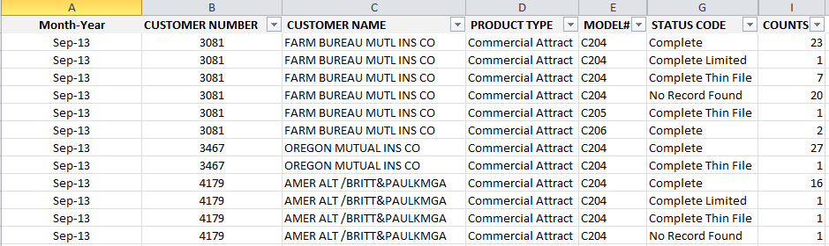

1. Consumer Disclosure – NA
2. Billing

Transactional Billing – 2 Report Codes

* 1. Billing Type - Transactional Insurance Detailed Billing
  2. Billing for this product should be included with all insurance products on one bill.
  3. Fulfillment/Finance has been approved
  4. Report Codes – 4 (Agents and Underwriters)

|  |  |  |  |  |  |  |  |  |
| --- | --- | --- | --- | --- | --- | --- | --- | --- |
| **Product**  **Group** | **Cost**  **Center** | **Report code #** | **Report code name** | **Stat code** | **Stat code name** | **UN or AGT** | **Long Description** | **Detailed Description** |
| COM | 351 | 5962 | COM ATT DRVR | AS00 | COM ATT DRVR SCORE | U | COMMERCIAL ATTRACT DRIVER SCORE |  |
| COM | 351 | 5963 | COM ATT DRVR MVR | AS00 | COM ATT DRVR MVR SCORE | U | COMMERCIAL ATTRACT DRIVER MVR SCORE |  |
| COM | 351 | 5965 | COM ATT DRVR | BB00 | AGENT COM ATT DRVR SCORE | A | AGENT COMMERCIAL ATTRACT DRIVER SCORE |  |
| COM | 351 | 5966 | COM ATT DRVR MV A | BB00 | AGENT COM ATT DRVR MVR SCORE | A | AGENT COMMERCIAL ATTRACT DRIVER MVR SCORE |  |

* 1. Special Requirements – N/A

1. Testing
2. QC
3. MOE
4. Legal Approvals
   1. Legal approval of PIR has been obtained.

By: Erika Hutt

Date: 5/13/2013

Restrictions, exceptions or outstanding issues: This is approved for use with only non-FCRA data listed within this PIR.  To the extent additional non-FCRA is to be added, legal will need to review and approve a different PIR.  Legal to also review any proposed reason codes to be provided out.  Subject to review of PMR and final signoff right before launch of product.

* 1. Legal approval of Baseline PMR has been obtained.

By: Erika Hut

Date: 2-07-14

Restrictions, exceptions or outstanding issues: Need meeting for final approval.

* 1. Legal approval of Final PMR has been obtained.

By: Erika Hut

Date: 3-19-14

Restrictions, exceptions or outstanding issues: Need email for final product launch approval.

* 1. Legal approval of Final Product Launch has been obtained via email.

By:

Date:

Restrictions, exceptions or outstanding issues:

1. Security Assessment
   1. Security/PSCO approval has been obtained.

iSIT Ticket # 2371506

By: Jarvis Robinson

Date: June 2013

Restrictions, exceptions or outstanding issues:NA

1. Sales Tax – NPE submitted 02-28-14 (resent request 3-20-14 and 3-26-14)

04-01-14 – Per Terence Stone, Taxware Enterprise Taxability Matrix code of 2038024 (Subscription fees charged for access to an online information database) best applies to this product.

|  |  |  |
| --- | --- | --- |
|  | **Questions for Assessing Taxability of product/service** | **Response** |
| 1 | What company / legal entity is selling the product/service? | LexisNexis Risk Solutions - Insurance |
| 2 | What is it exactly that we are selling?  Identify if there is a web site that has additional background information. | Attract Commercial Auto Underwriting (Drivers model) - Score |
| 3 | Are we selling this product/service to an end user or is it being resold? | Selling to end user |
| 4 | Who are the customers? | TBD |
| 5 | Is the product/service in an electronic or print format? | Electronic |
| 6 | What is the medium of transmission ( i.e. is the product/service shipped on a disk, e-mailed, load and leave, electronically transmitted, or accessed via software or a through a website)? | System to System |
| 7 | Is a software license being granted (i.e. a license to use computer software or the right to use and access computer software via software as a service model?) | N/A |
| 8 | Who initiates the transmission of the product/service? | Our Insurance Carriers/Customers |
| 9 | Do we send the product/service to the customer or does the customer retrieve it? | Customer Retrieves |
| 10 | Is there any tangible personal property associated with the sale of this product/service? | No |
| 11 | How do we bill for this product/service?  Is this a bundled charge or do we charge separately for different features of the product/service? | Transactional Billing |
| 12 | If the product/service includes data or information, is it personal and individual in nature such that no other customer can use the information? | Yes |
| 13 | Does this product/service generate any reports or files which can be used by other customers? | No. There is no “duplicate” ordering process for this product. |
| 14 | If there is a transmission of software or access to software via internet, is it canned or customized? | N/A |
| 15 | Can we obtain sample invoices or contracts? | Yes |
| 16 | Is this product shipped to or used in specific jurisdictions? | NA |
| 17 | Is this product / service used in multiple jurisdictions and if so, can we obtain a breakdown of the use in each jurisdiction? | NA |
| 18 | If the product is shipped, what are the terms of shipment?  Is a common carrier used?  Are goods dropped shipped? | NA |
| 19 | Is there a maintenance component to the sale?  If so, is it mandatory or optional? | NA |
| 20 | Are the different maintenance components separately stated on the customer invoices? | NA |
| 21 | What is the delivery method, load and leave, electronic, or TPP?  What does the customer receive via the maintenance component? (i.e. phone support, email support, computer software upgrades, etc.?) | NA |
| 22 | If the customer receives computer software upgrades, how are the upgrades provided (i.e. via diskette, emailed, downloaded, access through a website?) | NA |
| 23 | Who is the product champion that would be the best contact for additional information? | NA |
| 24 | What is the timeframe for rollout? | Connie Fitzsimmons, New Product Execution Manager, 678-694-5727 |
| 25 | Is this an entirely new product/service or is this a subsequent phase of an existing product/service?  Will there be additional phases that need to be considered? | New, No additional Phases for this PMR. |

**Appendices**

1. Appendix A– Modeling Document

**ATTRACTSM FOR COMMERCIAL AUTO UNDERWRITING (DRIVER MODEL)**

**NON-FCRA**

**(QB #1483)**

**Business Overview**

For the purposes of rating, Commercial insurers who write small to mid-size fleets traditionally collect detailed information related to the vehicles in the fleet. They procure information such the number of power units, gross vehicle weight (GVW), VIN, radius of operation, the use of the vehicles, and the three-year loss experience of the fleet. For many insurers, limited driver information such as years of experience, years employed, and age are used in policy rating. Insurers also pull MVR’s on individual drivers and charge for violations and accidents.

In a manner similar to private passenger auto rating, Commercial insurers desire to gather more detailed information on fleet drivers. This includes driver class (age, gender, and marital status), violation and accident history, credit, and other personal attributes predictive of the risk of loss. Ideally, they want to obtain this information in a cost effective manner and through a process that circumvents regulations associated with using credit reports. It is not a common practice for insurers to order credit-based insurance scores for individual drivers to evaluate fleet risks. However, the need to evaluate each driver’s performance with credit-like attributes exists in the marketplace.

**Solution Description**

The LexisNexis solution will utilize non-FCRA Public Record, MVR, and Length of Driving Experience attributes that are predictive of individual loss experience to develop a score for each driver in a given fleet. Generalized Linear Modeling (GLM) techniques have been used to build the models. The models will provide a score for each driver submitted in the fleet. This new information, combined with other traditional rating variables already used by the carrier, will enable Commercial insurers to make better underwriting and pricing decisions thus enhancing profitability and mitigating risk.

Two versions of the model have been built. The first version uses Non-FCRA Public Records, Length of Driving Experience, and MVR violations and accidents. Additional non-FCRA data sources such as Commercial CLUE may be added at a later time pursuant to additional PIR requests. For commercial carriers who request this version of the model, we will provide it only to the extent that an MVR or Activity File (or CLUE Enhanced MVR) is ordered concurrently with the model score. In order to preserve the non-FCRA status of the model, the MVR or Activity File must be ordered directly through the state. At this time, the DUP & DHDB cannot be accessed as these databases are closely regulated. However, a Non-FCRA MVR Retention Database is forthcoming in 2014.

The second version will exclude MVR attributes. Although MVR attributes add lift to the model, the second version is still very effective in rank ordering risky drivers.

**Modeling Process**

* The target variable (Y) is the risk of loss associated with an individual driver. Historical losses extracted from CLUE Auto© merged with MVR history from the same time period are used as the targets.
* The target data emanates from two groups. Group 1 is comprised of individual commercial drivers (based on commercially endorsed driver’s licenses) extracted from DHDB with prior MVR violations & accidents.
* Group 2 is comprised of CLUE Enhanced MVR extracts from six commercial carriers. These drivers may or may not have commercially endorsed DL’s.
* The model attributes have been be appended to the records for each group. Using GLM, the modelers determined which attributes (independent variables) were most predictive of the CLUE enhanced MVR extracts (target). The resulting models were then trained and validated on the two groups using different time periods.
* The first version of the model uses MVR violations & accidents, Public Records, and Length of Driving Experience attributes. The second version excludes MVR attributes.

**Modeling Process-Continued**

* The resulting models were further validated on actual Commercial Fleet Auto policies provided by Baldwin (Group 3). The models are very effective in rank ordering the average number of claims per quintile, and are reasonably effective in rank ordering loss ratio. Both models are able to single out drivers with high loss ratios in the worst quintile. The first version of the model grouped nearly 25% of all risky drivers in decile 1, while the second model singled out nearly 20% in decile 1.
* In order to further validate and/or fine tune the models, the modeling team has requested additional carrier policy datasets consisting of commercial fleet drivers. The Vertical is actively trying to acquire this data from key clients.

**Attributes**

Appendix A displays the Public Records, Length of Driver Experience, and MVR attributes that were most predictive of a risky driver. If no derogatory events are found for a given driver, the attributes listed under “Score Card One” will be used to develop the score. If one or more are found, the attributes listed under “Score Card Two” will be used to develop the score. The MVR attributes are utilized only in Version One of the model (C115).

**Required Input**

* The order from the customer will be the same as used to order an MVR.  The customer inquiry will need Data Enhancement (such as address) to obtain missing information needed for the order to public records.  Leveraging a process used to order CLUE Enhanced MVR’s, the LexID for each driver will be appended from the Insurance Header. From the LexID, the most probable address can be developed for each driver. If an MVR is ordered (Version 1), the address can be extracted from the MVR Wallet Data.
* The LexID for each driver will be used to append the appropriate attributes (depending on which version of model is used) to be consumed by the model to develop the score.

**Output and Delivery**

* As mentioned above, the model will produce a score for each driver from 200 to 997, where 200 = highest (worst) risk, 997 = lowest (best) risk. 998 & 999 are reserved for no-hits and no scores. Model indicators *will not* be returned.
* A composite score for the fleet will *not be* provided.
* The output will be delivered to the customer via MVR or an XML format when processing system to system. When ordering an MVR and the Score, the Score will be distinct from the MVR Report. For the purposes of POC (Proof of Concept), we will need the ability to process Retrospective Analyses. The Record Layout for this Analysis will be defined in a separate document.

**Contributory Requirements**

Although this solution does not utilize CLUE Commercial data attributes, the Vertical requires carriers to contribute to the CLUE Commercial database to purchase this model.

**Billing Requirements**

The Score is ordered either in addition to an MVR or in lieu of an MVR.

* MVR will generate a billing entry
* SCORE will generate its own billing entry

**QuickBase#1483**

Click [here](https://seisint.quickbase.com/db/be98uq7uq?a=dr&r=bqm) to see this Project Record within QuickBase (if you have permission).

**Appendix A - Attributes**

**Model C115**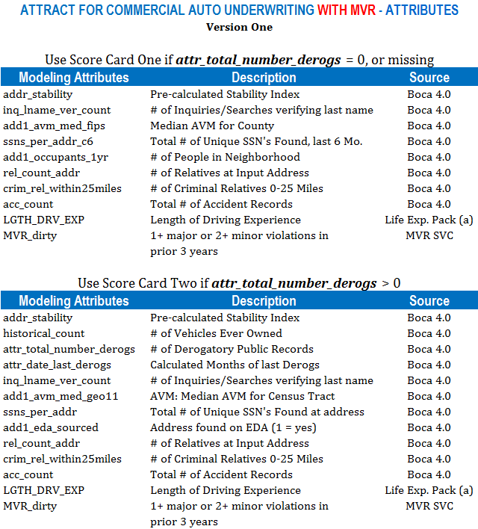

**Appendix A - Attributes**

**Model C114**

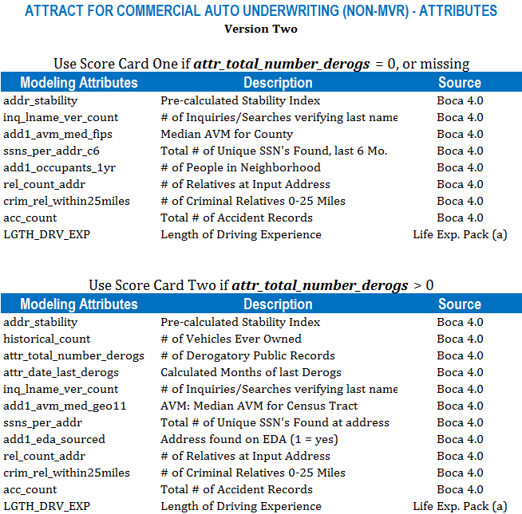

**Appendix A - Attributes**

Note (a) See below for the attributes used to construct the Length of Driving Experience in the Life Experience Pack.

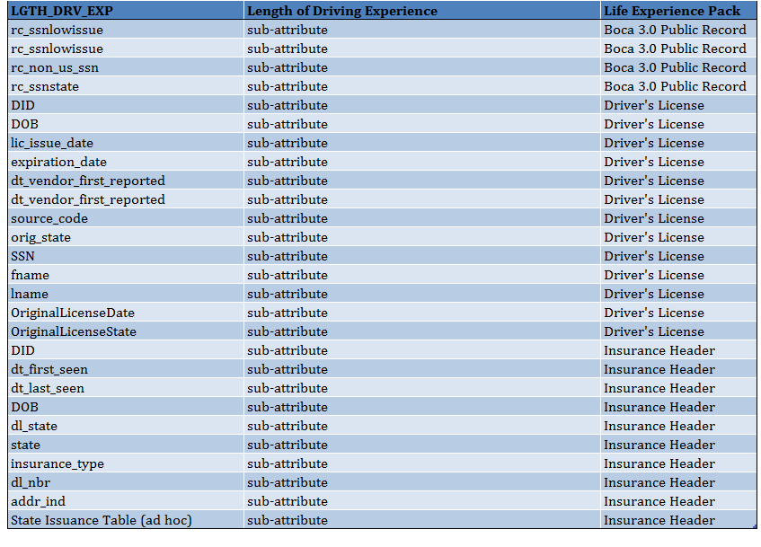

1. Appendix A – CR# 128

Change Request Details

|  |  |  |  |
| --- | --- | --- | --- |
| **PIR#/CR#** | PIR# 1483 - CR# 128 | | |
| **Related Project Record** | [Attract for Commercial Drivers Underwriting - Non-FCRA](https://seisint.quickbase.com/db/be98uq7uq?a=dr&rid=1483) | | |
| **Requestor** | [Fitzsimmons, Connie](https://seisint.quickbase.com/db/bh2jqvmmn?a=dr&r=ea) | | |
| **Change Request Name** | Agent Report Codes | | |
| **Change Request Type** | Requirement Oversight | | |
| **Change Request Description** | We need to add agent report codes to MBSi. | | |
| **Attachment 1** |  | | |
| **Attachment 2** |  | | |
|  |  | | |
| **Technology/Project Manager(s)** | [Ben Saunders](https://seisint.quickbase.com/db/bh2jqvmmn?a=dr&r=ea) | | |
| **Submit for Review?** | Yes | **Date Submitted for Review** | 03-06-2014 |

Change Request Impact Assessment

|  |  |  |  |
| --- | --- | --- | --- |
| **Assessment Provided By** | [Saunders, Ben](https://seisint.quickbase.com/db/bh2jqvmmn?a=dr&r=ea) | | |
| **Assessment Status** | Complete | **Assessment Completion Date** | 03-11-2014 |
| **Comments** | Per Chris Tolbert (MBSi Lead), the high level estimate for this change is 4-5 days. | | |
| **Attachment 1** |  | | |
| **Attachment 2** |  | | |

Change Request Decision Status

|  |  |  |  |
| --- | --- | --- | --- |
| **Decision Provided By** | [Patel, Hemi](https://seisint.quickbase.com/db/bh2jqvmmn?a=dr&r=ea) | | |
| **Change Request Decision** | Approved | **Decision Date** | 03-11-2014 |
| **Decision Status Comments** |  | | |

Created on March  6 at 11:38 AM (EST). Last updated by [Fitzsimmons, Connie](https://seisint.quickbase.com/db/bh2jqvmmn?a=dr&r=ea) today at 10:28 AM (EDT). Owned by [Fitzsimmons, Connie](https://seisint.quickbase.com/db/bh2jqvmmn?a=dr&r=ea).

Show fields from Show fields from Show fields from a related table a table related to ""



Bottom of Form